SKILL-1
T. Siva Harsha Vardhan Reddy
2400030361
Section-09

Screen Shots:

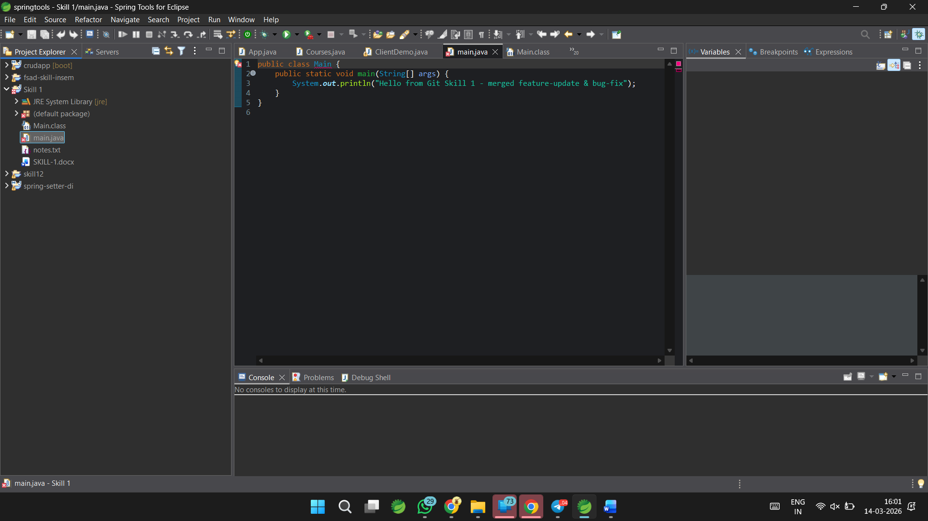

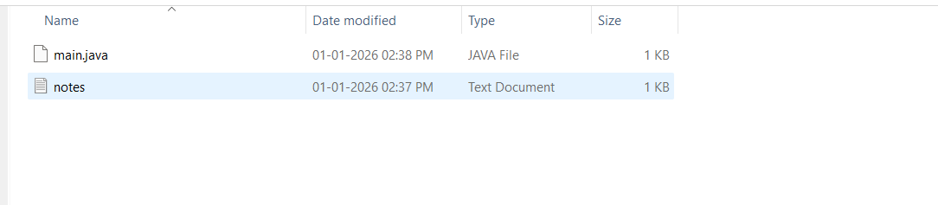
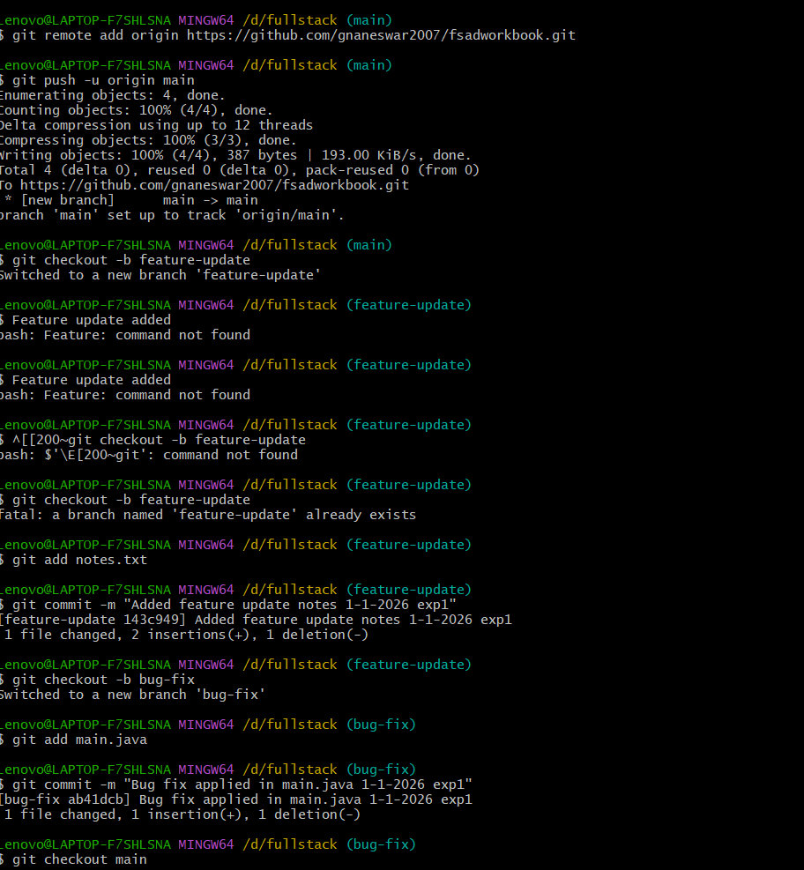
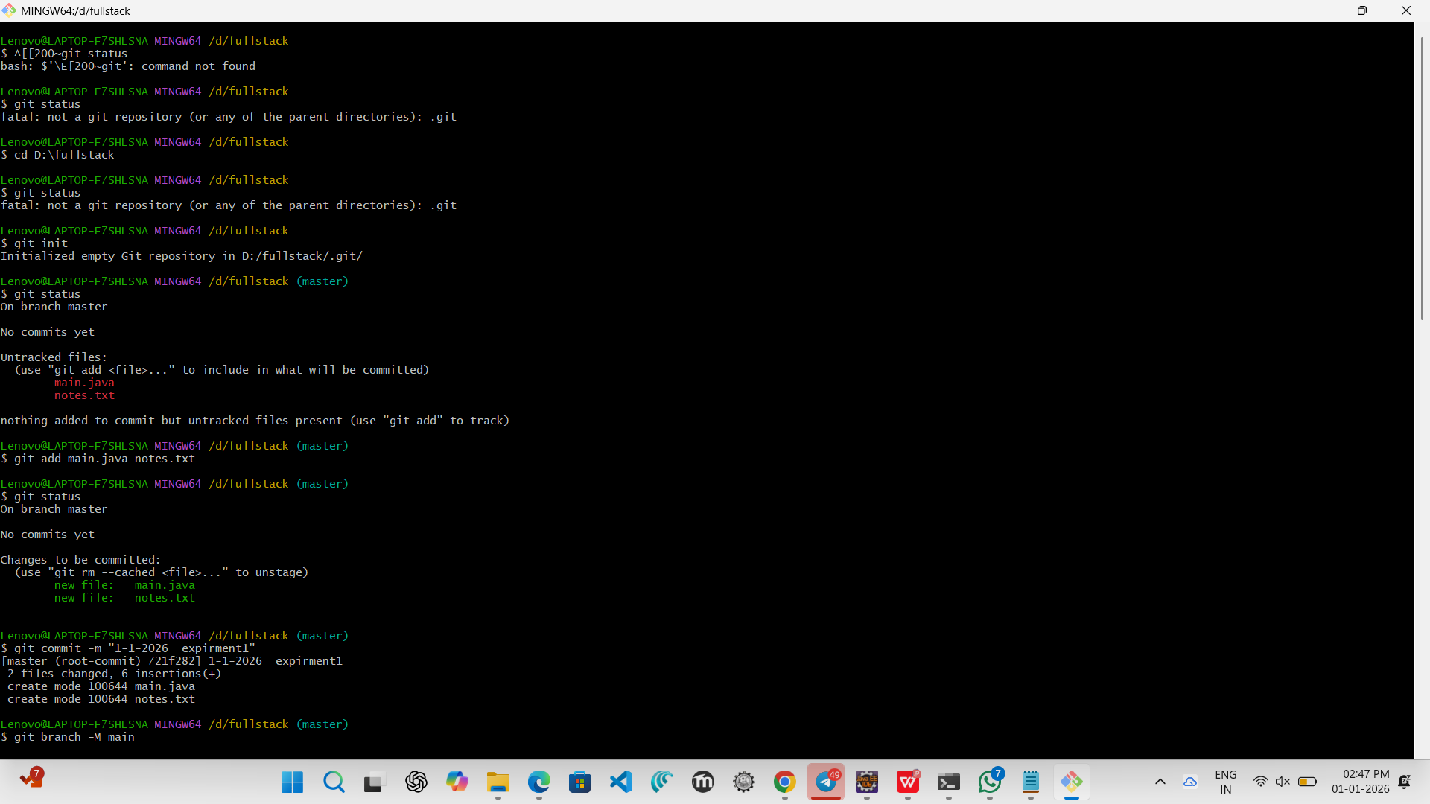
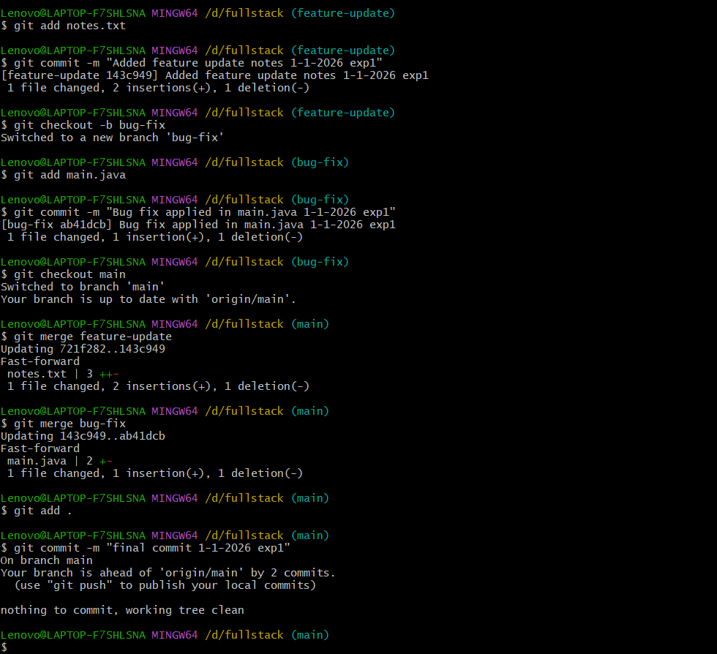

Github REPO Link:
https://github.com/harsha08-2k6/FSAD-WORKBOOK.git
